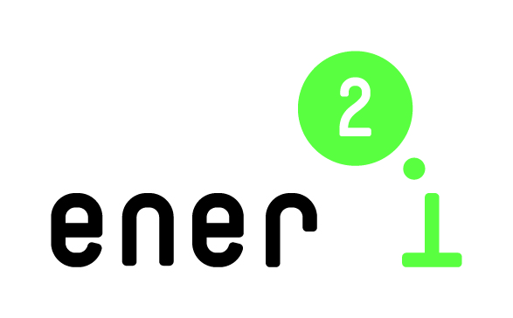

ener2i cooperation profile for brokerage event

Date
October 14, 2014

Venue
Minsk, Belarus
Energy Expo and Congress,
Address: Roofed Soccer Arena, 20/2 Pobediteley ave., Minsk

ener2i is a project financed by the European Union. The ener2i Brokerage Event serves to broker contacts between colleagues from business and research from Belarus and EU countries, who deal with energy efficiency and renewable energy issues. Please fill in the following cooperation profile, which will be made available to registered participants of the brokerage event in advance.

Participant Details

First Name /Last Name:
Organisation Name:
Position in organization:
e-mail:
Organisation Type: Research Organisation/University/Business/Other
Organisation Size: 1-10 / 11-50 / 50-250/250+
Country:

I apply for an ener2i travel grant for the brokerage event: Yes/No
(A travel grant will cover economy return flight, hotel and visa cost of participants from EU)

Also, I would like attend the ener2i Training Workshop “Innovation in Energy Efficiency and Renewable Energy” on October 15, 2014: Yes/No

Your expertise

Please describe briefly your expertise and field of activity.

Expected result

What would you like to get out of the brokerage meetings? E.g. do you have a project idea and are looking for partners, or are looking for a project to participate in? Please specify. In the case you are looking for partners, which partners are you searching for?

Data for an invitation letter for visa purposes (for those who need visa) and accommodation

Date of birth:
Passport number:
Passport valid till:
Citizenship:
I need assistance with reservation of a hotel: Yes/No
Dates: from/to
Room type: single/double
(Basing on this request a hotel will be recommended to you by the local organizer. Upon getting your agreement, room reservation will be made if needed).

